**GREYHOUND BREEDING AND WHELPING STATISTICS NSW FY 18/19**

Published in GWIC Reports and Statistics

To provide transparency about what is happening on the breeding front for greyhounds in NSW the Commission publishes information it receives about breeding services (capturing both natural matings and artificial insemination) and litters whelped on a monthly basis. An overview of both year to date trend line data and more detailed monthly information is provided below. This information is based on data reported by participants and processed by the Commission in the relevant month.

**Overview of year to date breeding and whelping**

The following graphs display trend line data that shows both monthly and year to date data in respect of services and whelpings.

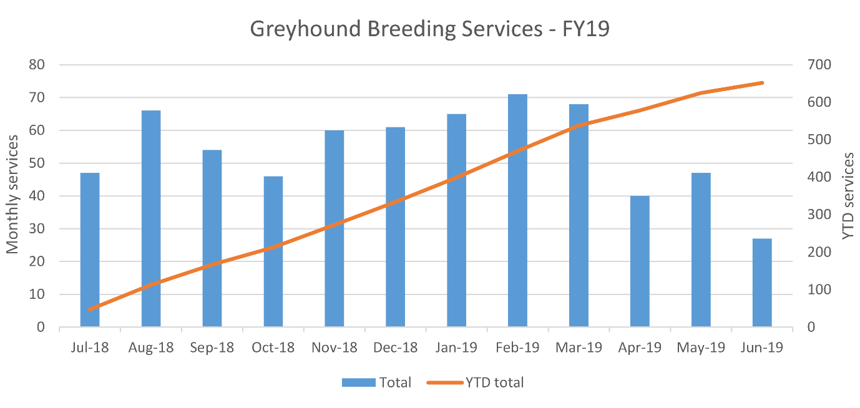**Graph 1. Greyhound Breeding Services:** number of services each month and the total number of services year to date.

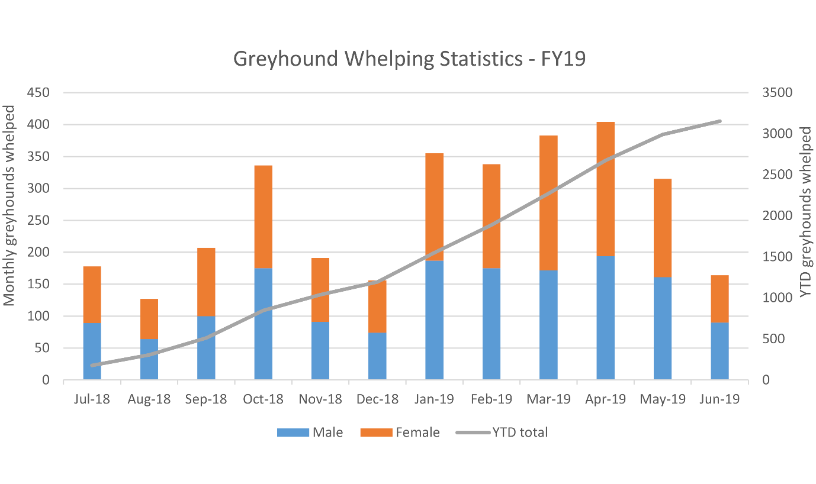**Graph 2. Greyhound Whelping Statistics:** number of puppies whelped each month and the total number of puppies whelped year to date.