BAN GREYHOUND RACING

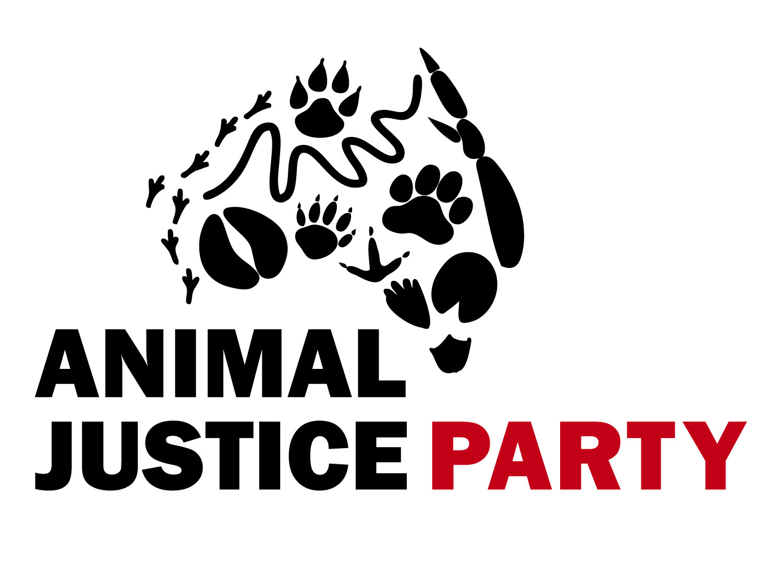
This petition notes that:
- Between 13,000 and 17,000 healthy young dogs are killed each year by the greyhound racing industry in Australia.
- Up to 90% of trainers are alleged to have participated in the barbaric practice of live baiting.
- The industry has failed to reform in any meaningful way to stop the routine mistreatment of animals.
- Dogs are being exported to jurisdictions with no animal welfare protections, including Macau, where they are subject to poor living conditions, risk of serious injury and a certain death.
- The greyhound racing industry is a poor employment generator and its continuation is inconsistent with the public interest.
- The greyhound racing industry is a gambling industry and significantly contributes to problem gambling.

The petitioners below call on the Victorian government to:
- ban all greyhound racing in Victoria.
- Use the assets currently held by the industry regulator to fund a Greyhound Racing Transition task force to assist industry employees find new work and to facilitate the homing of dogs.
- Prohibit the export of greyhounds for racing or breeding purposes

FULL NAME | ADDRESS + POSTCODE | SIGNATURE | EMAIL (OPTIONAL)
*Please mail original signed petition to Dr Eleonora Gullone, AJP Victoria, P.O. Box 91, Kew East, 3102

FULL NAME | ADDRESS + POSTCODE | SIGNATURE | EMAIL (OPTIONAL)

